Final Project Report: Food Ordering Behavior Data Analysis
​1. Introduction
  - ​Project Overview:

This project analyzes customer behavior, preferences, and operational patterns within a food ordering ecosystem using a dataset of 50,000 records (food_ordering_behavior_dataset.csv).

Using Tableau, data is transformed into actionable visual insights regarding regional demand, meal dynamics, spending habits, and service quality.
​1.2 Objectives:
- ​Identify top customer cuisine preferences across different metro cities.
- ​Evaluate order volume trends across meal types, times of day, and dining companions.
- ​Analyze operational metrics including delivery times and customer satisfaction ratings.
- ​Build an interactive Tableau Dashboard and Story presentation to support data-driven decision-making.
​2. Project Initialization and Planning Phase
​2.1 Define Problem Statement:
Food delivery platforms struggle to optimize regional marketing, menu positioning, and delivery logistics without understanding how customer demographics, mood, time, and dining companion influence ordering decisions.
​2.2 Project Proposal (Proposed Solution):
Develop a comprehensive Tableau analytical workspace containing 8 distinct visual analyses, an executive dashboard, and a narrative-driven story to pinpoint key operational and customer demand patterns.
​2.3 Initial Project Planning:
Structured into data ingestion, data cleaning in Excel/Tableau, visualization framing, dashboard layout design, story creation, and final documentation.
​

3. Data Collection and Preprocessing Phase
​3.1 Data Collection Plan and Raw Data Sources Identified:
​Dataset Name: food_ordering_behavior_dataset.csv
​Location / URL: https://drive.google.com/file/d/1__bBUnmTq2-QQMZXj_QqQdSqjwgS8ABS/view

​3.2 Data Quality Report:
Verified 50,000 records for completeness. Corrected data types for fields including Order ID, User ID, Age, City, Cuisine, Meal Type, Order Value, Delivery Time Taken, and Rating Given. No missing values detected.
​3.3 Data Exploration and Preprocessing:
Aggregated metrics, formatted numerical variables, grouped continuous age parameters into analytical bins, and categorized categorical variables for smooth Tableau ingestion.
​4. Data Visualization
​4.1 Framing Business Questions & 4.2 Developing Visualizations
​ ​1. What are the key performance indicators (KPIs) for overall business performance?
- ​ Visualization: Text / KPI Cards displaying Total Revenue, Average Order Value (AOV), and Average Rating.

Screenshot of Visualization:
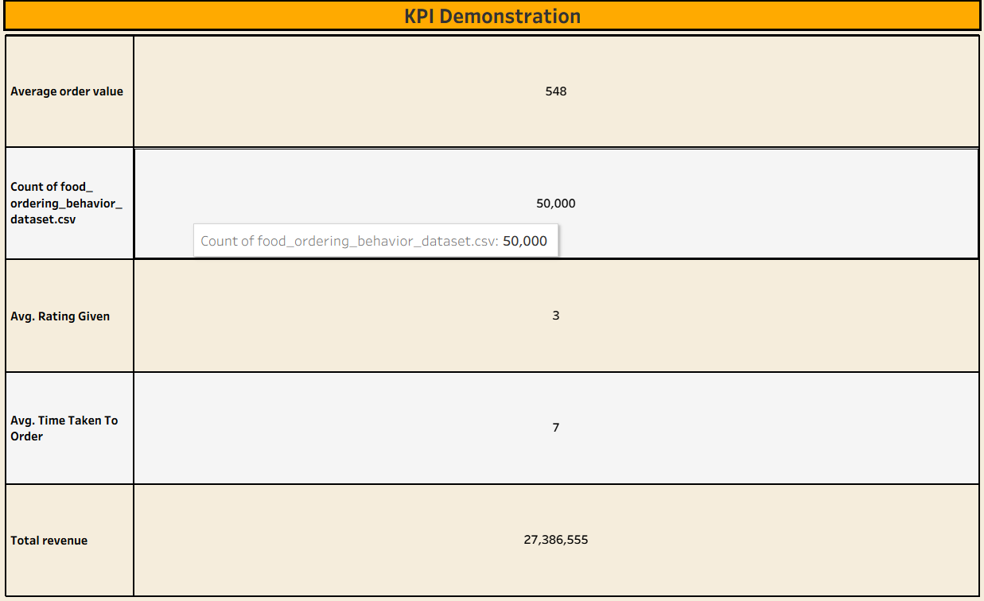

2. Which cuisines are most popular across different cities?
- ​ Visualization: Heatmap / Highlight Table showing Cuisine vs. City to identify regional demand patterns.

Screenshot of visualization:
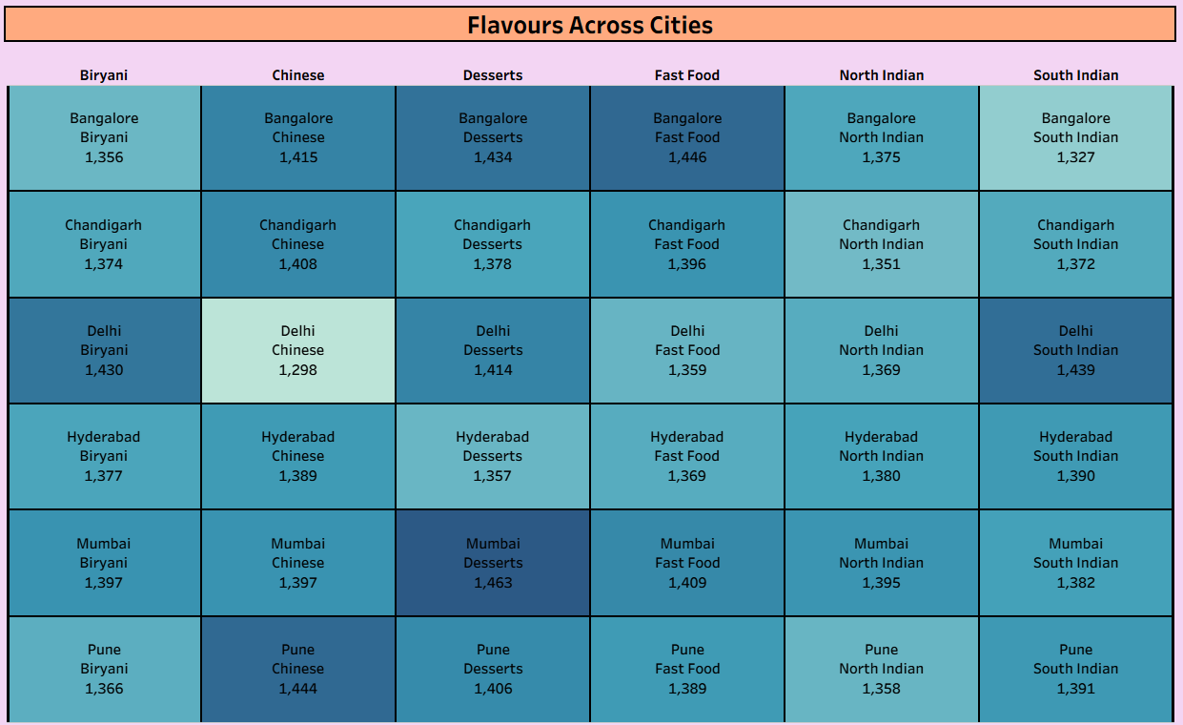
​3. How do order volumes and average spending vary across different age groups?
- ​ Visualization: Bar Chart comparing total order count and average order value by Age Bins.

Screenshot of Visualisation:
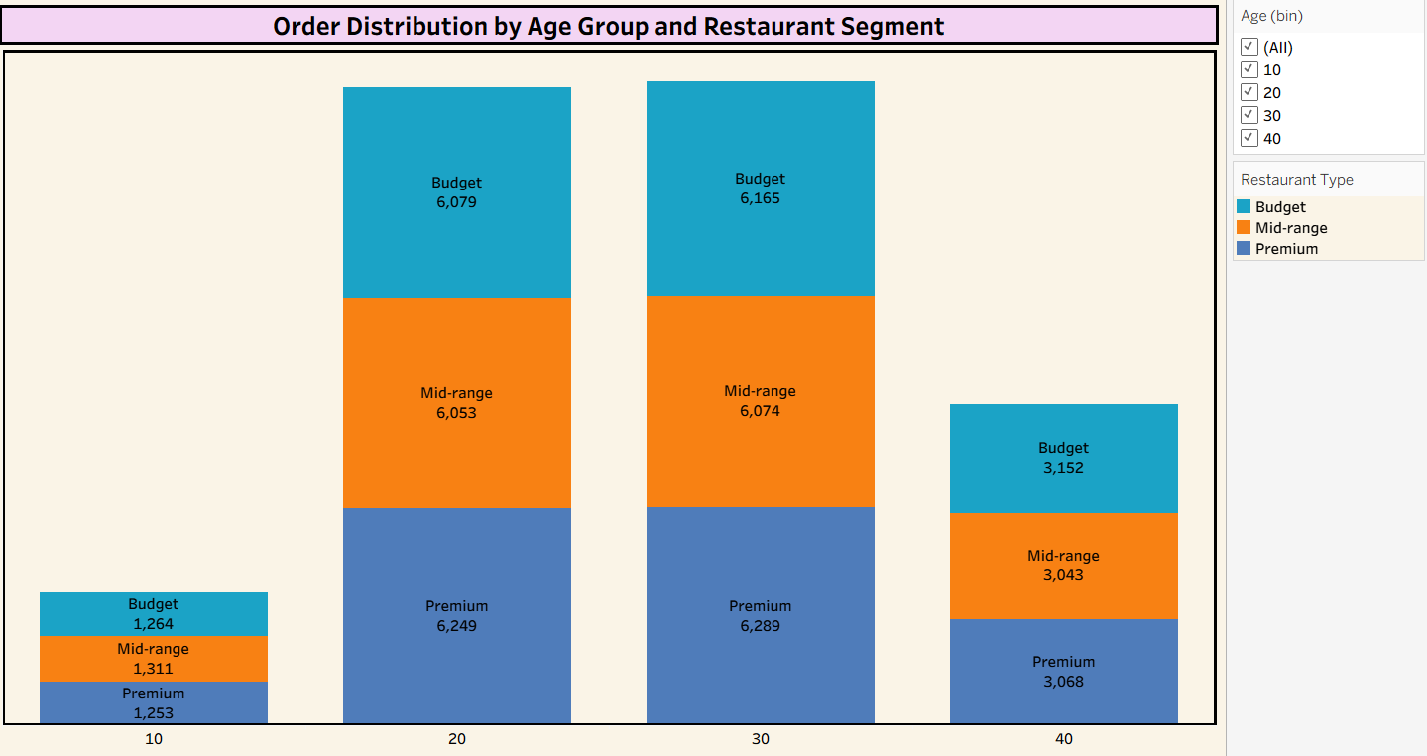

4. How does delivery time impact customer rating scores?

- Visualization: Horizontal Bar Chart comparing average delivery time by cities.
​
Screenshot of visualization:
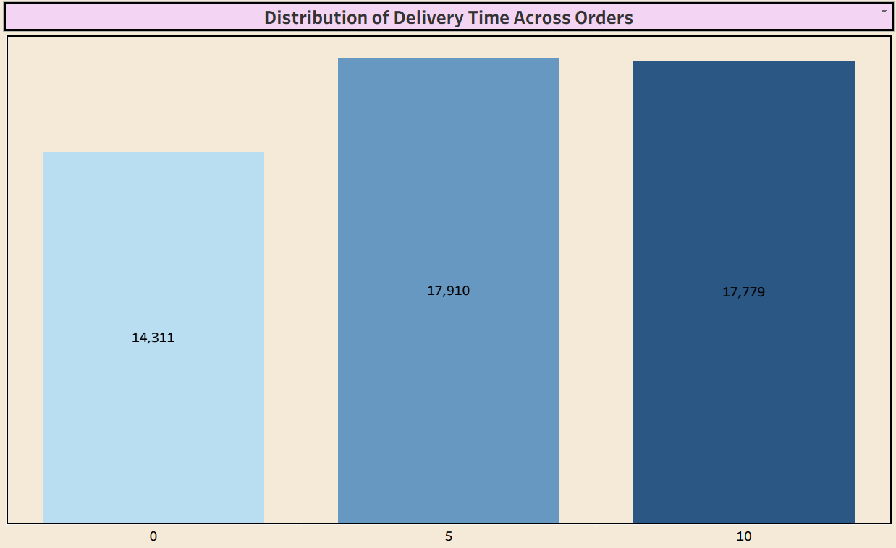

​

5. Which meal types (Breakfast, Lunch, Dinner, Snacks) generate the highest total revenue?
​
- Visualization: Bar chart comparing revenue share by Meal Type.
​

Screenshot of visualization:
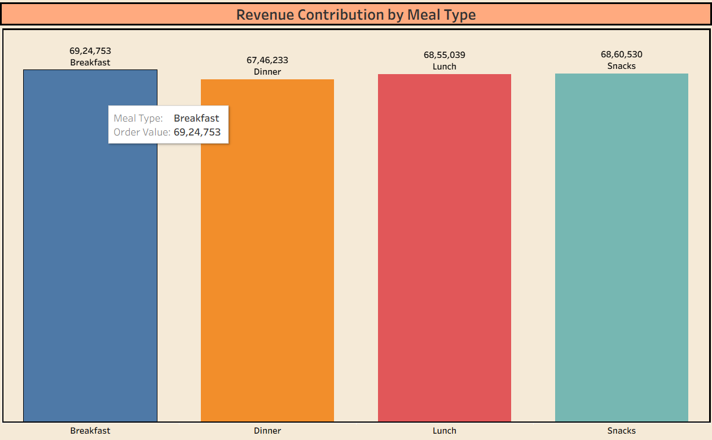

​6. Which cuisine types are most preferred by customers based on order volume?

​Visualization: Pie chart showing the distribution of customer preferences across different cuisines.

​Screenshot of visualization:
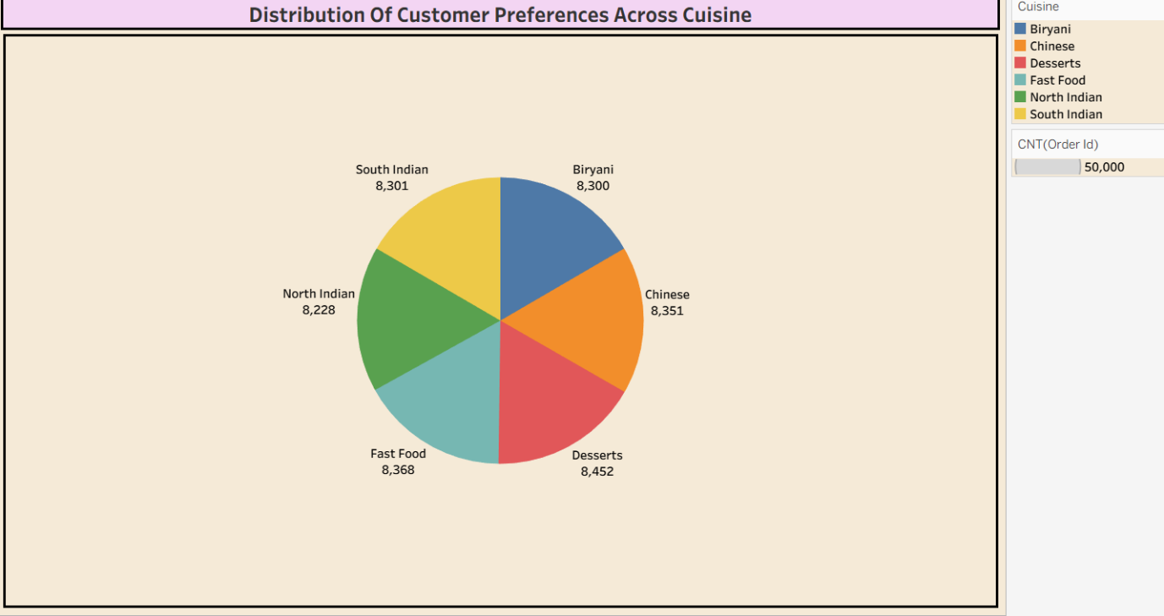
​
7. How does order volume vary across dining companion types and meal types?

​ Visualization: Bar Chart analysing order counts grouped by meal type and company type.

​Screenshot of visualization:
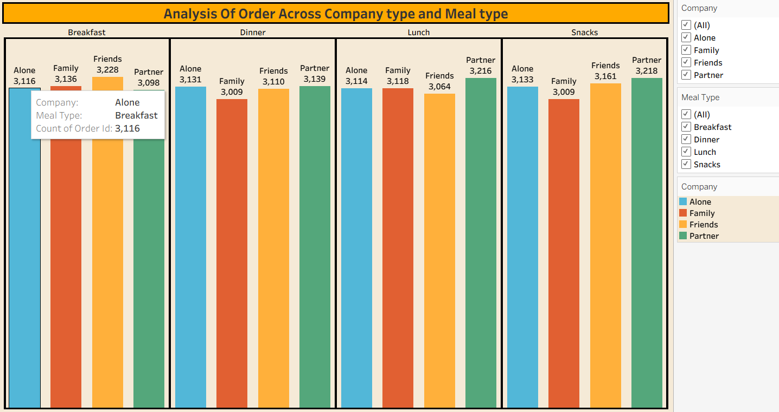

​

8. What is the distribution of total order volumes across different cities?

​Visualization: Bar Chart showing total order count grouped by City.
​Screenshot of visualization:
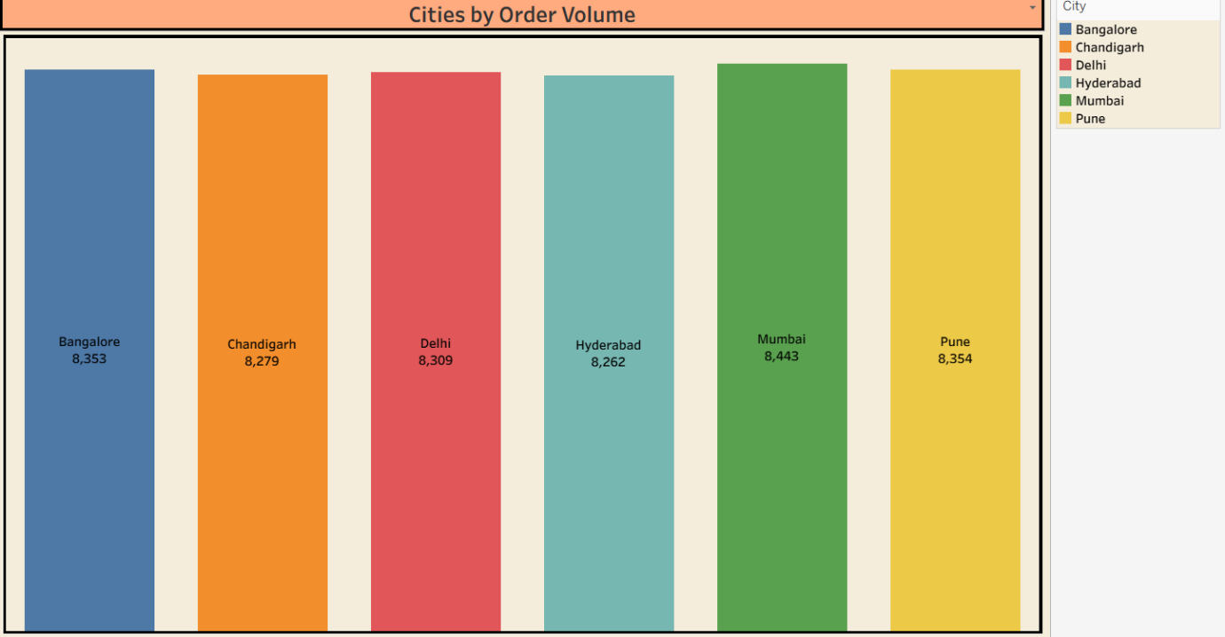
​5. Dashboard
​5.1 Dashboard Design File:
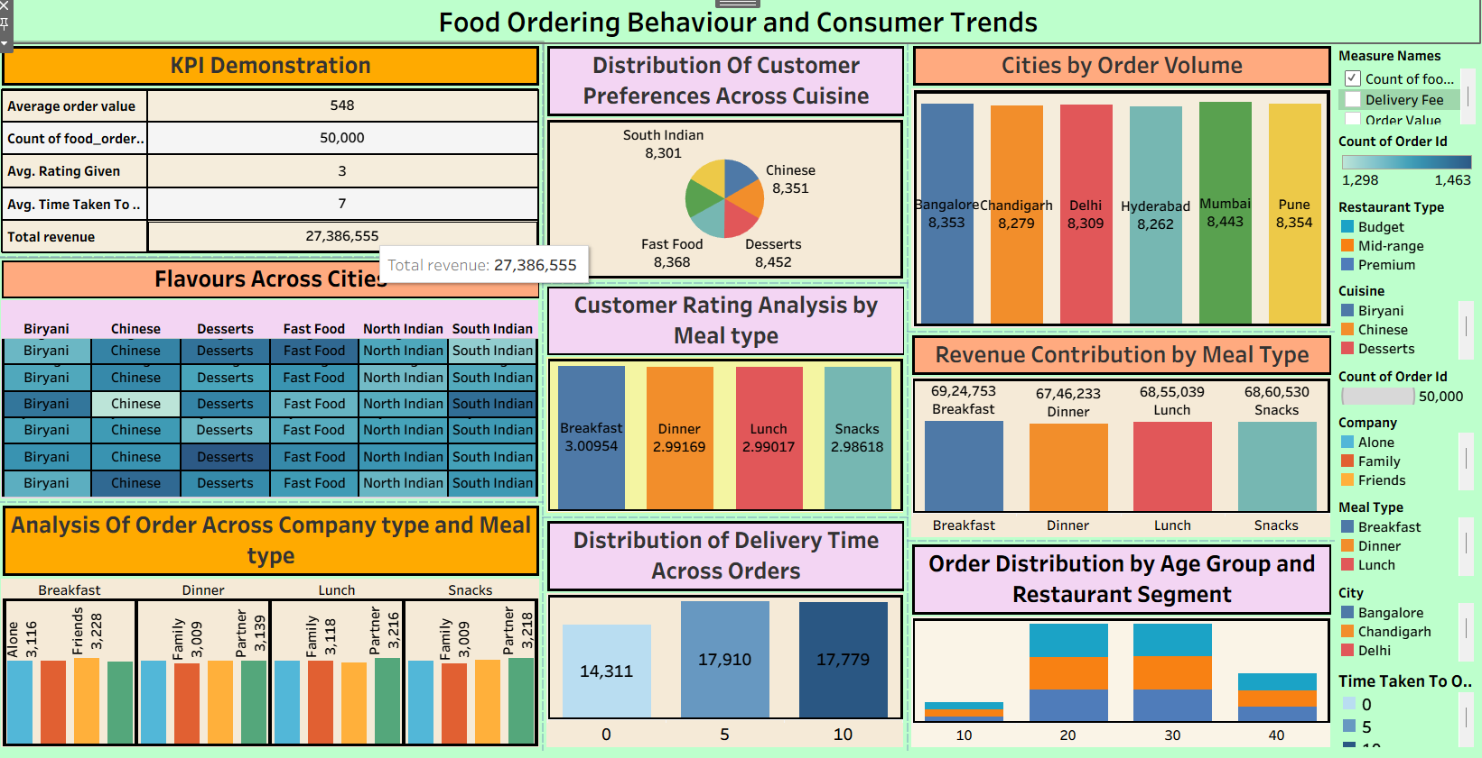​ Major Dashboard Outcomes:
​Overall Business Overview: The dashboard summarizes key metrics showing consistent customer engagement across major metro cities, with high order volumes distributed evenly between lunch and dinner peak hours.
​Top Cuisine Preferences: Desserts and Fast Food lead customer preference trends, followed closely by Chinese and South Indian orders.
​Geographic Order Distribution: City-level volume remains balanced across Bangalore, Pune, Mumbai, Delhi, Hyderabad, and Chandigarh, indicating steady regional coverage.
​Dining Dynamics by Meal Type: Group orders (Friends and Partner) represent a significant portion of peak meal periods, while individual orders dominate snack time slots.
​Service Rating Performance: Customer satisfaction scores maintain high consistency across all order types, providing clear benchmarks for operational delivery standards.
​6. Report
​6.1 Story Design File:
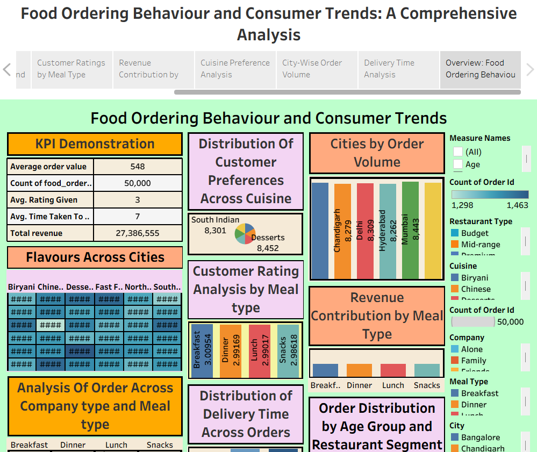​
​

Key Narrative Points:

​Macro Performance & Volume Overview:
Across a dataset of 50,000 total orders, the business generated 27,386,555 in total revenue with an Average Order Value (AOV) of 548, maintaining a steady 3-star rating average.
​

Equal Geographic Market Demand:
City-wise order volume shows balanced market penetration across major regions, led by Mumbai (8,443 orders), Pune (8,354 orders), Delhi (8,309 orders), and Chandigarh (8,279 orders).
​Balanced Cuisine Preferences:
Customer preference distribution is evenly spread across all major cuisine categories, with Desserts leading at 8,452 orders, closely followed by Fast Food (8,368) and Chinese (8,351).
​Meal Type Revenue & Operational Efficiency: Revenue and order volume remain consistent across all meal categories (Breakfast, Lunch, Dinner, and Snacks), supported by an optimized average delivery time of 7 minutes.
​7. Performance Testing
​7.1 Utilization of Data Filters:
Applied interactive global data filters for City (Bangalore, Chandigarh, Delhi, Hyderabad, Mumbai, Pune), Cuisine (Biryani, Chinese, Desserts, Fast Food, North Indian, South Indian), Meal Type (Breakfast, Dinner, Lunch, Snacks), and Age, allowing seamless dynamic filtering across the dashboard and story tabs.
​7.2 No of Calculation Fields
Created 2 calculated fields (for metrics aggregations and order counting performance).
​7.3 No of Visualization:
Developed 8 individual worksheets, 1 interactive central dashboard (Overview: Food Ordering Behaviour and Consumer Trends), and 1 multi-tab story presentation with 6 narrative story points (Customer Ratings by Meal Type, Revenue Contribution by Meal Type, Cuisine Preference Analysis, City-Wise Order Volume, Delivery Time Analysis, and Overview).
​8. Conclusion / Observation
- ​ Overall Scale & Revenue: The business achieved a total revenue of 27,386,555 across 50,000 orders, maintaining an Average Order Value (AOV) of 548 and a stable average delivery time of 7 minutes.
- ​Even Regional & Category Demand: Market demand is evenly distributed across all 6 major cities (led by Mumbai with 8,443 orders and Pune with 8,354) and across all major cuisines, with Desserts (8,452 orders) and Fast Food (8,368 orders) as top choices.
- ​Meal & Companion Dynamics: Revenue generation and order volume remain consistent across all meal slots (Breakfast, Lunch, Dinner, Snacks), with dining companion types (Alone, Family, Friends, Partner) showing steady involvement across peak hours.
- ​Service Rating Benchmarks: Customer rating scores hold steady at an average of 3 stars across all meal types, signaling dependable operational consistency across different delivery regions.
​9. Future Scope
- ​ ​Predictive Demand & Order Forecasting: Implement machine learning algorithms to predict peak order volumes and demand spikes for specific cuisines based on weather patterns, public holidays, and local events.
- ​Delivery Route & Time Optimization: Expand the dataset to include geospatial GPS tracking data to analyze specific delivery bottlenecks and optimize driver routing to further reduce the average 7-minute delivery window.
- ​Customer Lifetime Value (CLV) & Loyalty Segmentation: Integrate customer-level transaction histories to build predictive CLV models and design personalized promotional discounts for high-value repeat customers.
- ​Dynamic Menu & Pricing Strategies: Utilize mood and dining companion insights to create dynamic time-based bundling offers (e.g., family combo deals for dinner, targeted snack discounts for solitary afternoon orders).

​10. Appendix
​
​10.1 GitHub & Project Demo Link:
​GitHub Repository Link:
https://github.com/chokkamlikitha02-hash/food-ordering-behaviour-tableau-project
Tableau Public Dashboard Link:
https://public.tableau.com/app/profile/chokkam.likitha/viz/tableau_project_intern/Dashboard1?publish=yes
Tableau Public Story:
https://public.tableau.com/app/profile/chokkam.likitha/viz/tableau_project_intern/Story1?publish=yes

